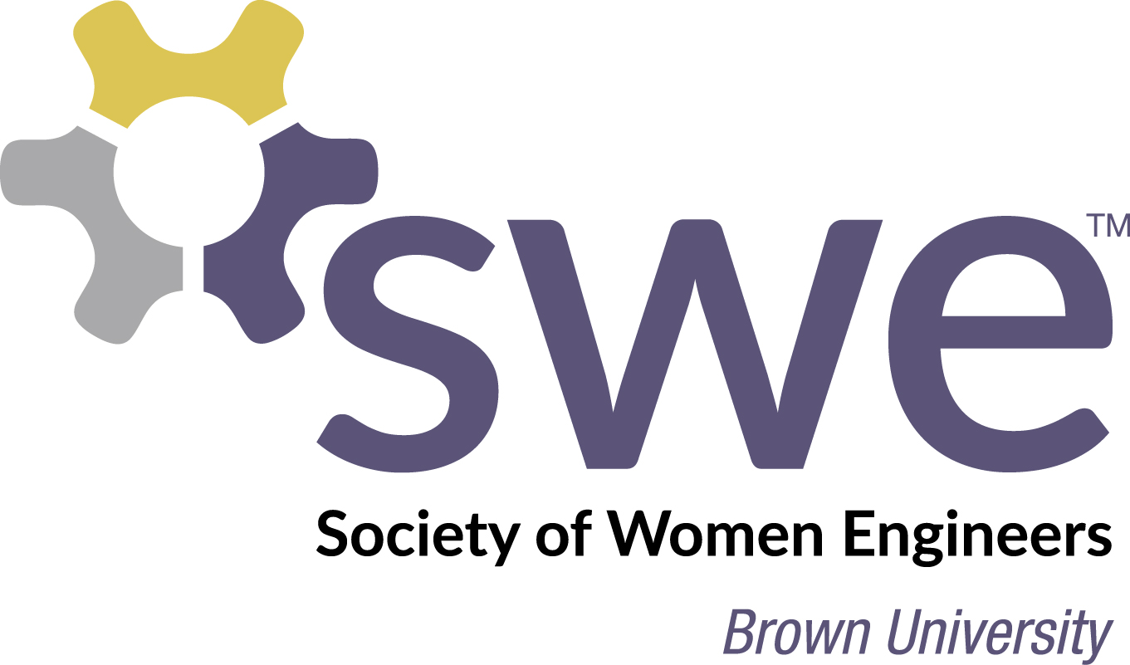

Within the Brown community, SWE promotes women in engineering by organizing community-building activities, sponsoring professional development opportunities, and forming mentoring relationships between upperclassmen and first year engineering students.
By sponsoring SWE, your organization will support women in engineering and engineering education at Brown; enhance the visibility of your products and services to students, faculty, alumni, researchers, and higher education leaders associated with Brown; and, enhance your organization's ability to outreach and recruiting to top engineering student for internships and full-time career opportunities.

Sponsorship Opportunities
PLATINUM SUPPORTER — $3,000+
- Platinum Supporter will appear on Brown SWE website
- Acknowledgement on promotional materials
- Printing of logo on event t-shirts
- On-campus display of corporate logo
- Acknowledgement on event welcome slide
- Invitation to attend Brown SWE events

GOLD SUPPORTER — $1,000-$2,999
- Gold Supporter will appear on Brown SWE website
- Acknowledgement on promotional materials
- Acknowledgement on event welcome slide
- Invitation to attend Brown SWE events

SILVER SUPPORTER — < $1000
- Silver Supporter will appear on Brown SWE website
- Acknowledgement on event welcome slide
- Invitation to attend Brown SWE events
Sponsorship Areas
Sponsorship may be directed to one of our three main programming focuses. Alternatively, sponsorship can be directed to the general fund.

MENTORSHIP
- Mentorship program connecting upperclassmen mentors with underclassmen students
- Community building events at Brown

PROFESSIONAL DEVELOPMENT
- Career panels featuring alumni and professionals from the local area
- Workshops on networking, resume writing, and interviewing
- Attendance at SWE conferences

OUTREACH
- Math and science tutoring program for K-12 students in Rhode Island
- Events that excite, encourage, and expose younger students to engineering and science

Thank you for consideration of our request to support the Brown Society of Women Engineers. Your support will make our continued success possible. I hope you will join with us as we foster the academic and professional development of women entering into the engineering field.

To Sponsor Brown SWE:
Please make complete the enclosed form and send it along with your support to:

Brown University School of Engineering
Attn: Nancy Carroll
182 Hope Street
Providence, RI 02912

Please provide a corporate logo that we can use to advertise your sponsorship and let us know if you would like to sponsor a specific area.

Questions or Comments? Please contact us at brownuswe@gmail.com

